Git clone and commits from Visual Studio code

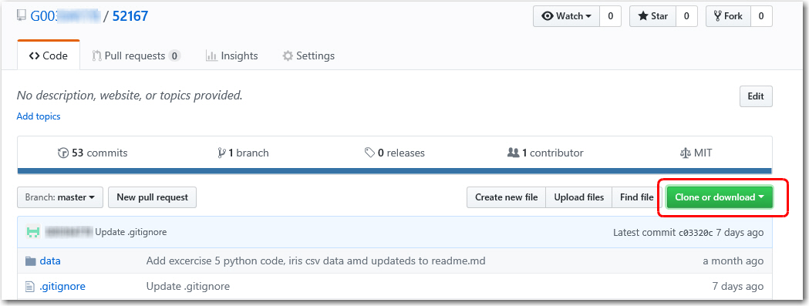

Open your Git repository that you want to clone and click on the “clone or download box”

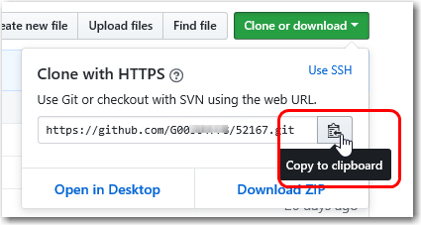

From there select copy to clipboard. If prompted allow permission to access clipboard.

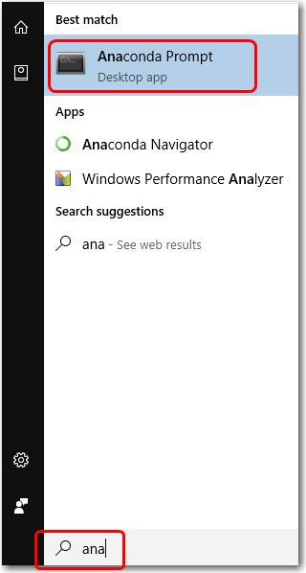

Launch anaconda prompt or a dos shell. The Launch anaconda type “ana” into the search bar and select.

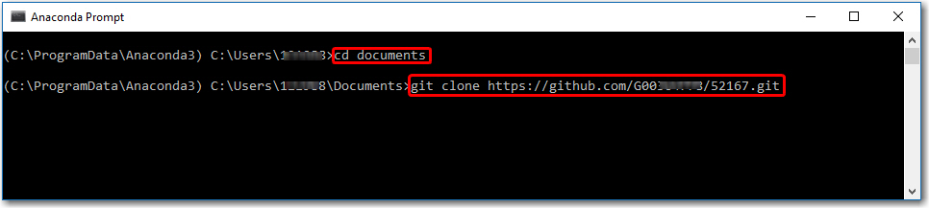

When launched change into the directory where you want the cloned project to reside, i.e. “cd documents” lets me clone my project “52167” into the documents folder.

Now enter the command ”git clone “ followed by a space and right click your mouse in the screen to paste the past previously copied by the “copy to clipboard” step.

Now enter and cloning should happen like this.

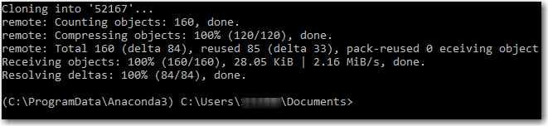

Once clone open you documents folder in windows explorer and right click and select “open with code”

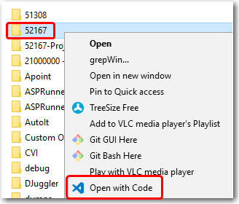

Now you should see the new cloned content is visual studio code.

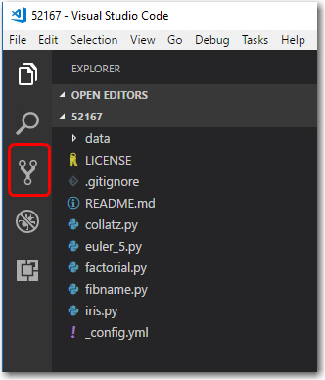

When any updates occur, they will appear in the source control tab.

Commits needs to be done in three steps, stage, commit with comment and push.

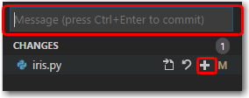

The commands are available under the … circled below

